**Ministerul Educației și Cercetării al Republicii Moldova**

**Universitatea Tehnică a Moldovei**

**Facultatea Calculatoare, Informatică şi Microelectronică**

**Departamentul Informatică şi Ingineria Sistemelor**

**RAPORT**

Lucrare de laborator nr.2

la cursul „Analiza si Sinteza Dizpozitivelor Numerice”

**Tema:**„ Sinteza convertoarelor de cod”

Varianta 3

A efectuat: **st. gr. TI-214 Buza Cătălin**

A verificat:  **asistent univ. Ursu Adriana**

**Chișinău 2022**

SarcinăȘ

1.Alcătuiți tabela de adevăr pentru funcțiile logice 𝑦1ș𝑖𝑦2.

2.Minimizați funcțiile 𝑦1ș𝑖𝑦2.-Determinati elementele commune,-Inlocuiti elementele commune.

3.Creati circuitul convertorului de cod in LogicWorks .

4.Determinati costul(C) si reinerea de timp(rT).

|  |  |  |
| --- | --- | --- |
| **Nr.var** | **Codul binar-zecimal de intrare** | **Codul binar-zecimal de iesire** |
| 3 | 8 4 1 (-2) | 5 2 2 1 |

1. Convertorul binar-zecimal:

|  |  |  |  |  |  |  |  |  |  |
| --- | --- | --- | --- | --- | --- | --- | --- | --- | --- |
|  | **Codul binar-zecimal de intrare** | | | |  | **Codul binar-zecimal de iesire** | | | |
| 8 | 4 | 1 | -2 |  | 5 | 2 | 2 | -1 |
| **x1** | **x2** | **x3** | **x4** |  | **y1** | **y2** | **y3** | **y4** |
| **0** | 0 | 0 | 0 | 0 |  | 0 | 0 | 0 | 0 |
| **1** | 0 | 0 | 1 | 0 |  | 0 | 1 | 0 | 1 |
| **2** | 0 | 1 | 0 | 1 |  | 1 | 0 | 1 | 1 |
| **3** | 0 | 1 | 1 | 1 |  | 0 | 1 | 1 | 0 |
| **4** | 0 | 1 | 0 | 0 |  | 1 | 0 | 0 | 1 |
| **5** | 0 | 1 | 1 | 0 |  | 0 | 1 | 0 | 0 |
| **6** | 1 | 0 | 0 | 1 |  | 1 | 0 | 1 | 0 |
| **7** | 1 | 0 | 1 | 1 |  | 1 | 1 | 1 | 1 |
| **8** | 1 | 0 | 0 | 0 |  | 1 | 0 | 0 | 0 |
| **9** | 1 | 0 | 1 | 0 |  | 1 | 1 | 0 | 1 |
|  |  |  |  |  |  |  |  |  |  |
| **10** | 0 | 0 | 0 | 1 |  | * | * | * | * |
| **11** | 0 | 0 | 1 | 1 |  | * | * | * | * |
| **12** | 1 | 1 | 0 | 0 |  | * | * | * | * |
| **13** | 1 | 1 | 0 | 1 |  | * | * | * | * |
| **14** | 1 | 1 | 1 | 0 |  | * | * | * | * |
| **15** | 1 | 1 | 1 | 1 |  | * | * | * | * |

1.1 Tabel de Adevar

|  |  |  |  |  |  |
| --- | --- | --- | --- | --- | --- |
|  | 8 | 4 | 2 | 1 |  |
|  | x1 | x2 | x3 | x4 | +/- |
| **0** | 0 | 0 | 0 | 0 | + |
| **1** | 0 | 0 | 0 | 1 | - |
| **2** | 0 | 0 | 1 | 0 | + |
| **3** | 0 | 0 | 1 | 1 | - |
| **4** | 0 | 1 | 0 | 0 | + |
| **5** | 0 | 1 | 0 | 1 | + |
| **6** | 0 | 1 | 1 | 0 | + |
| **7** | 0 | 1 | 1 | 1 | + |
| **8** | 1 | 0 | 0 | 0 | + |
| **9** | 1 | 0 | 0 | 1 | + |
| **10** | 1 | 0 | 1 | 0 | + |
| **11** | 1 | 0 | 1 | 1 | + |
| **12** | 1 | 1 | 0 | 0 | - |
| **13** | 1 | 1 | 0 | 1 | - |
| **14** | 1 | 1 | 1 | 0 | - |
| **15** | 1 | 1 | 1 | 1 | - |

1. 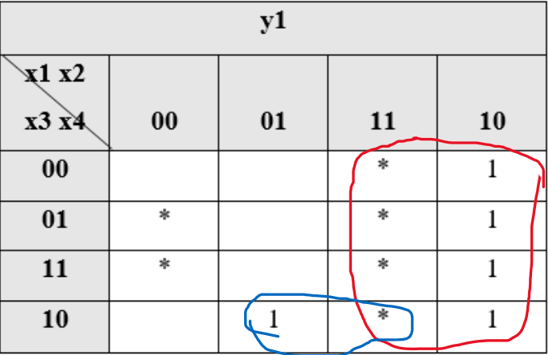**Minimizarea functiilor** y1 , y2, y3, y4:

|  |  |  |  |  |
| --- | --- | --- | --- | --- |
| **y1** | | | | |
| **x1 x2**  **x3 x4** | **00** | **01** | **11** | **10** |
| **00** |  |  | * | 1 |
| **01** | * |  | * | 1 |
| **11** | * |  | * | 1 |
| **10** |  | 1 | * | 1 |

y1 $=x_{1}+x_{2}x_{3}\overline{x_{4}}$

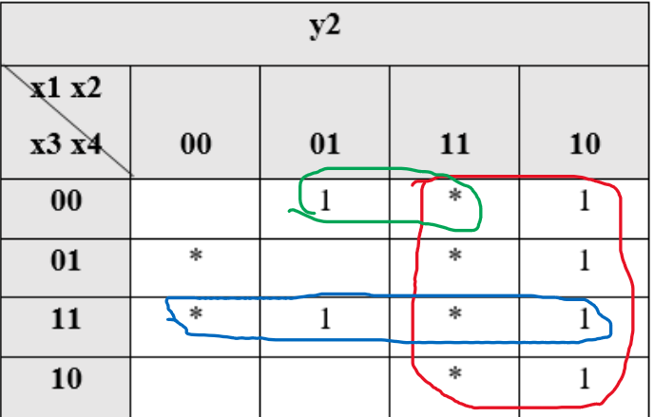

|  |  |  |  |  |
| --- | --- | --- | --- | --- |
| **y2** | | | | |
| **x1 x2**  **x3 x4** | **00** | **01** | **11** | **10** |
| **00** |  | 1 | * | 1 |
| **01** | * |  | * | 1 |
| **11** | * | 1 | * | 1 |
| **10** |  |  | * | 1 |

$$y2=x_{1}+x_{2} \overline{x_{3}} \overline{x_{4}}+x_{3}x_{4}$$

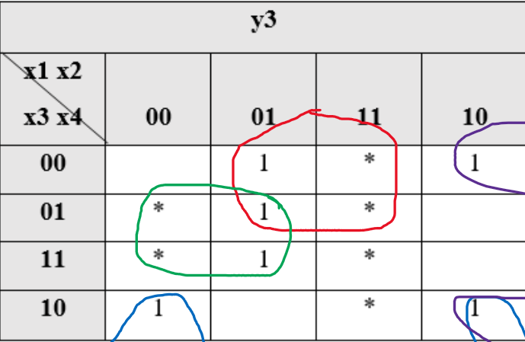

|  |  |  |  |  |
| --- | --- | --- | --- | --- |
| **y3** | | | | |
| **x1 x2**  **x3 x4** | **00** | **01** | **11** | **10** |
| **00** |  | 1 | * | 1 |
| **01** | * | 1 | * |  |
| **11** | * | 1 | * |  |
| **10** | 1 |  | * | 1 |

|  |  |  |  |  |
| --- | --- | --- | --- | --- |
| **y4** | | | | |
| **x1 x2**  **x3 x4** | **00** | **01** | **11** | **10** |
| **00** |  |  | * | 1 |
| **01** | * |  | * | 1 |
| **11** | * | 1 | * |  |
| **10** | 1 |  | * |  |

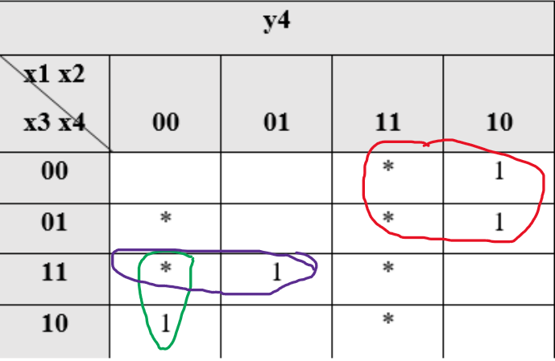 $$y4=x_{1}\overline{x_{3}}+x_{2}x_{3}x_{4}+\overline{x_{1}} \overline{x_{2}} x_{3}$$

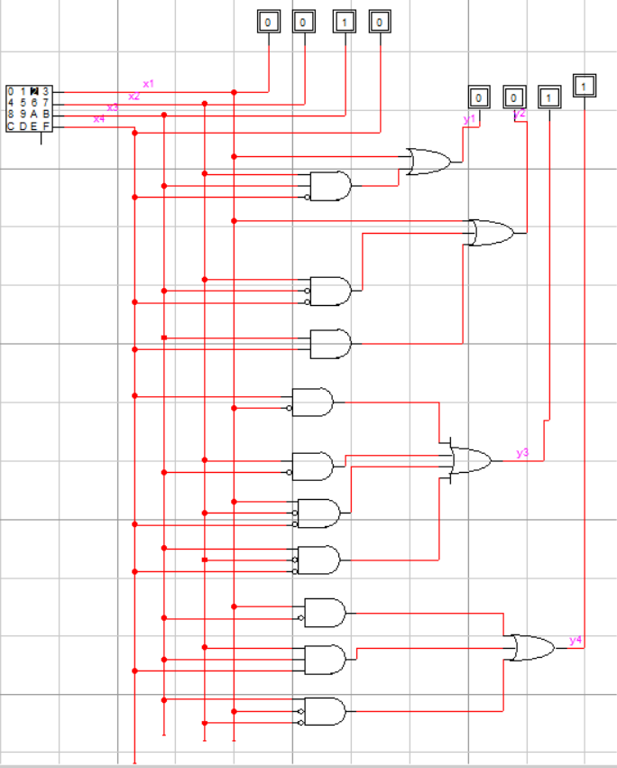

Diagrama de timp:

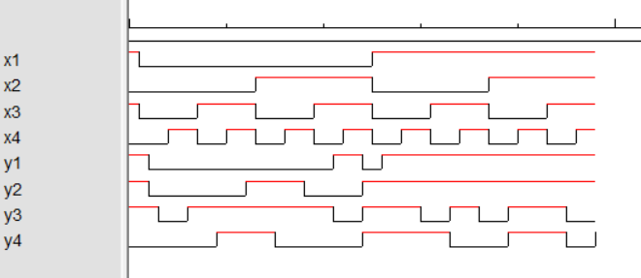

Costul=2;

Timpul de reținere=38;

Concluzie:

Efectuind lucrarea data am facut cunostinta cu sinteza convertoarelor de cod.Am aflat ca acestea sunt niste circuite logice combinationale cu n intrari si m iesiri,ammai aflat ca m si n pot fi atit egale cit si diferite in dependenta de tipul de coduri la intrareasi respectiv de la iesirea convertorului de cod.